DBMS Technical Task
Dhanalakshmi K
E25AI110
BSc. Computer Science
With
Artificial Intelligence

Week 6: Product Review and Rating Management System

The e-commerce platform aims to gather feedback from customers about the products they have purchased.
Customers can submit ratings and written reviews once their orders are completed.
The system will maintain these reviews, evaluate product performance, and recognize well-rated products.

- Create Review and Rating Tables:
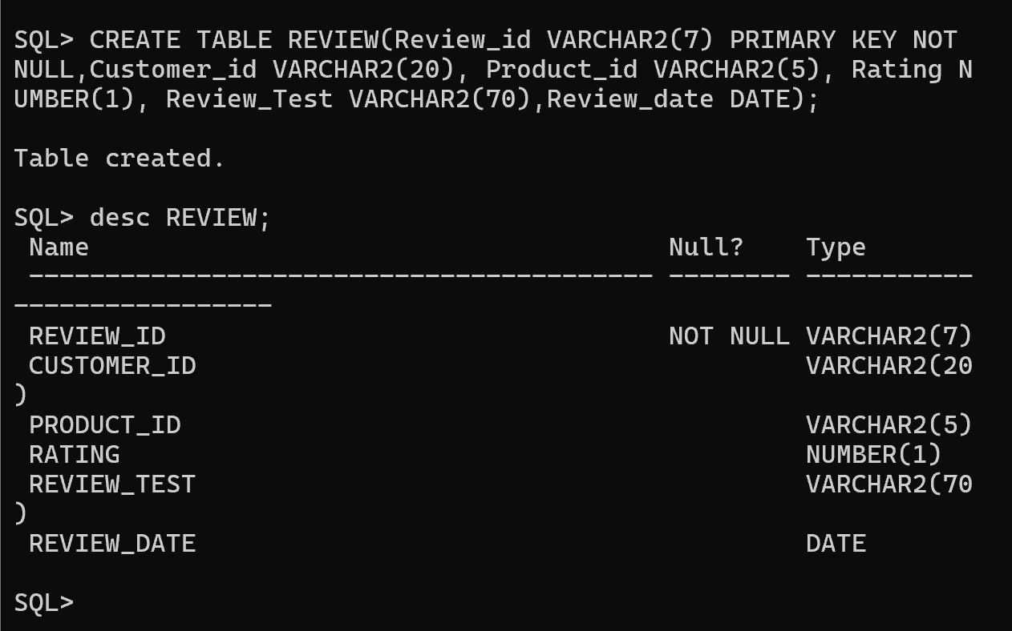

2.Store Customer Feedback and Ratings
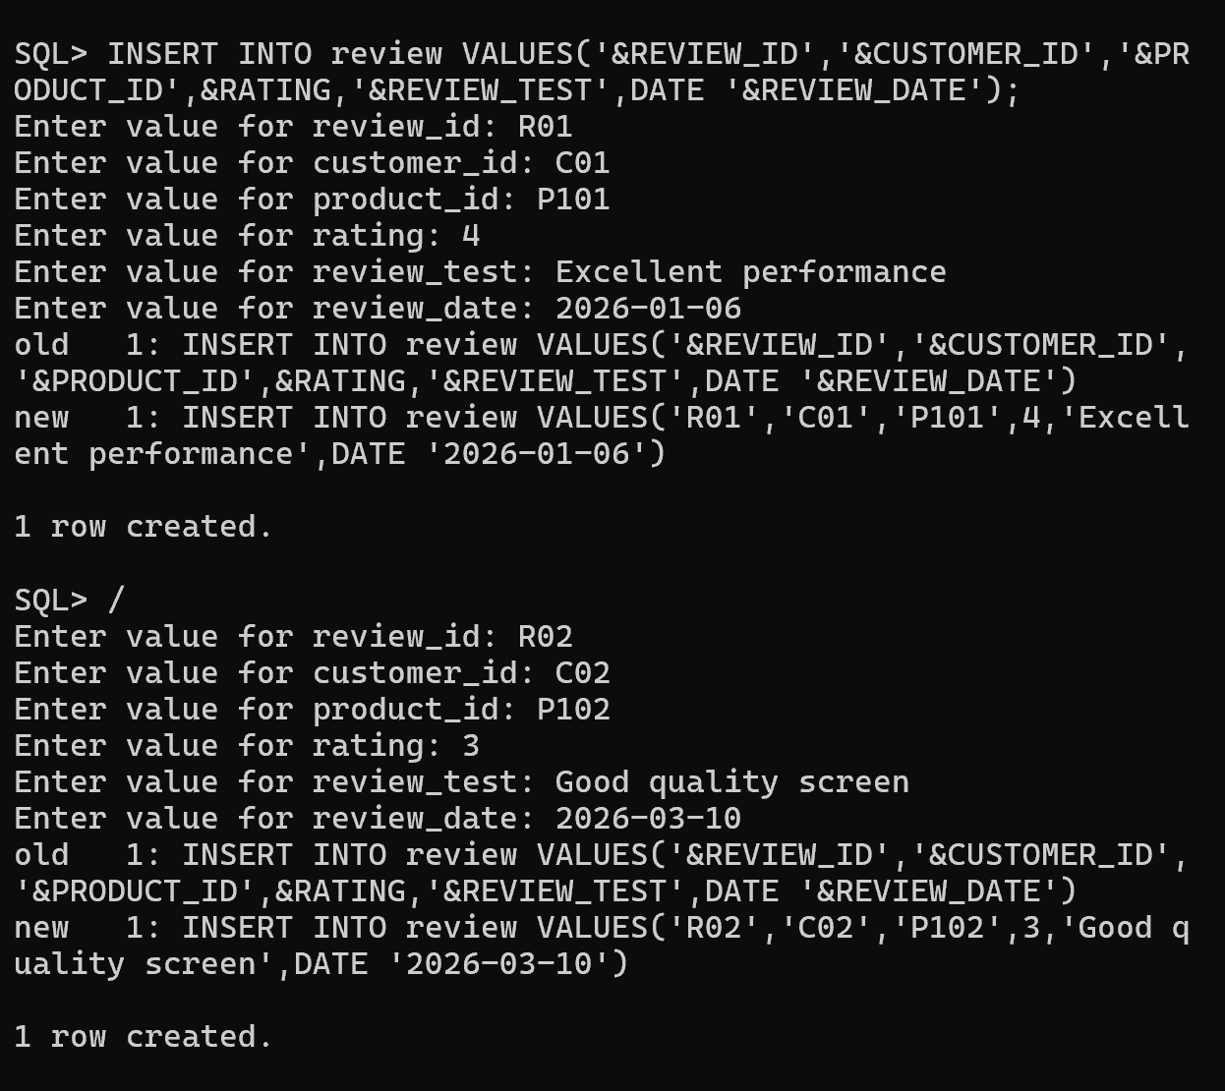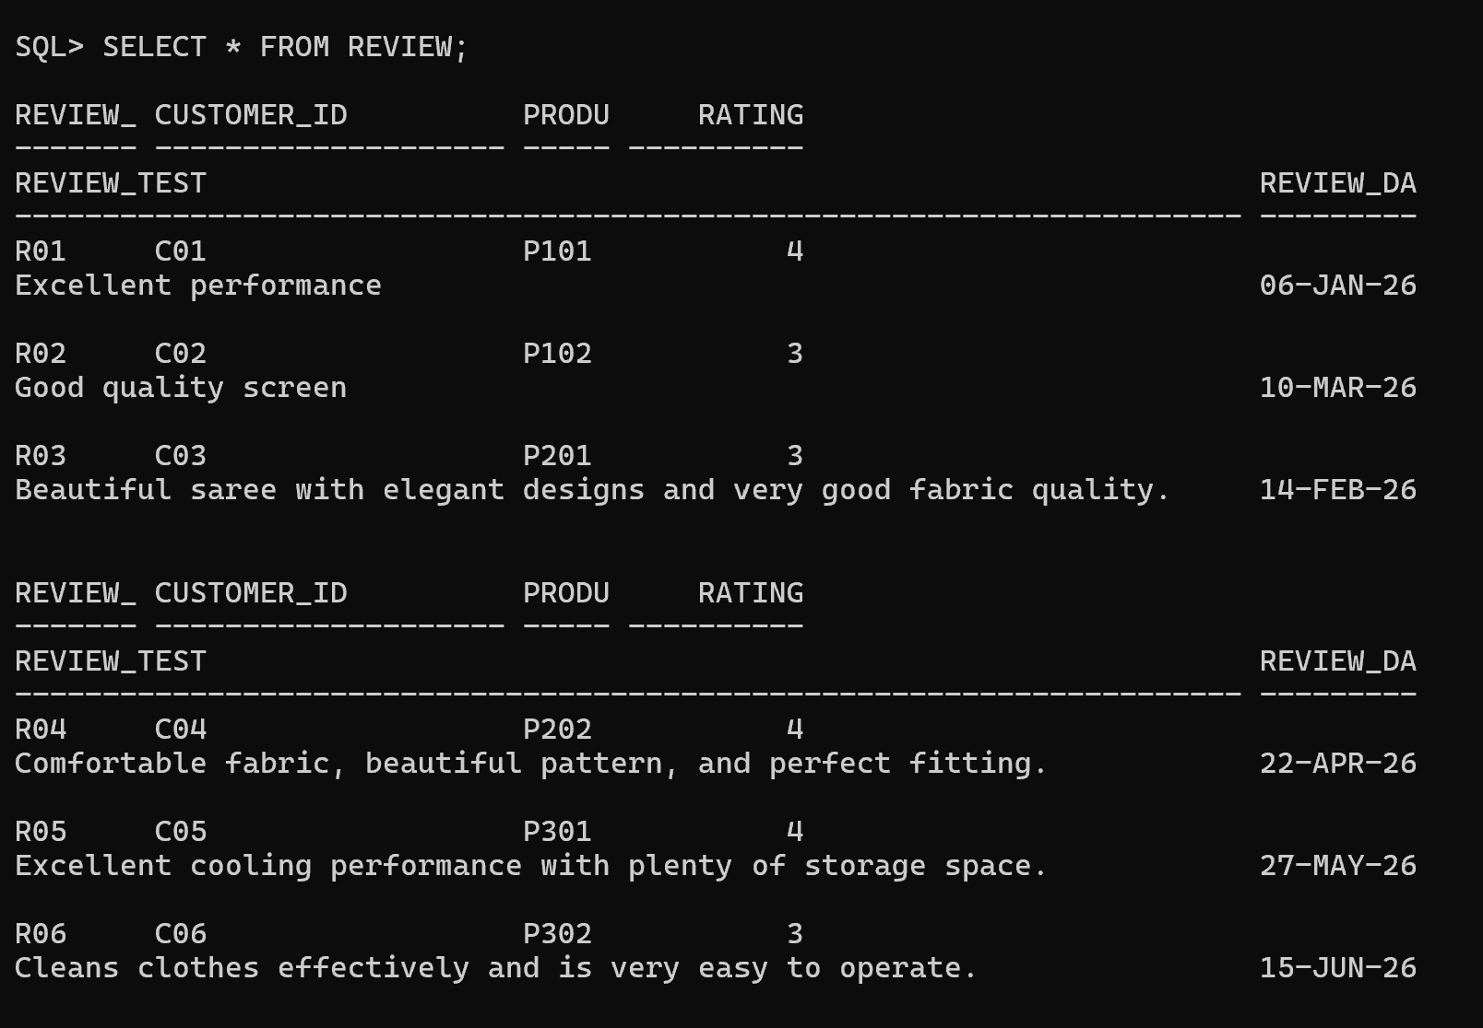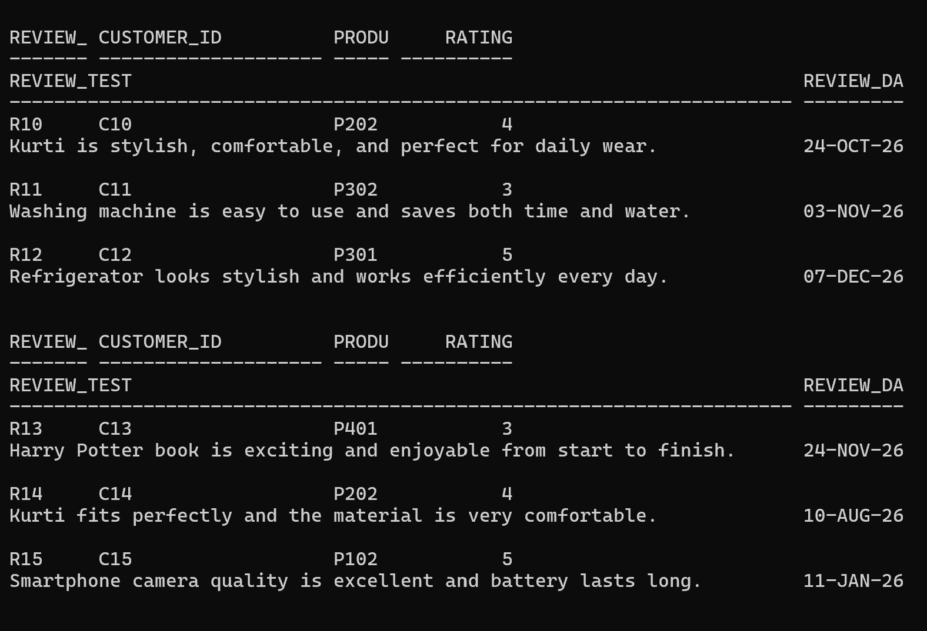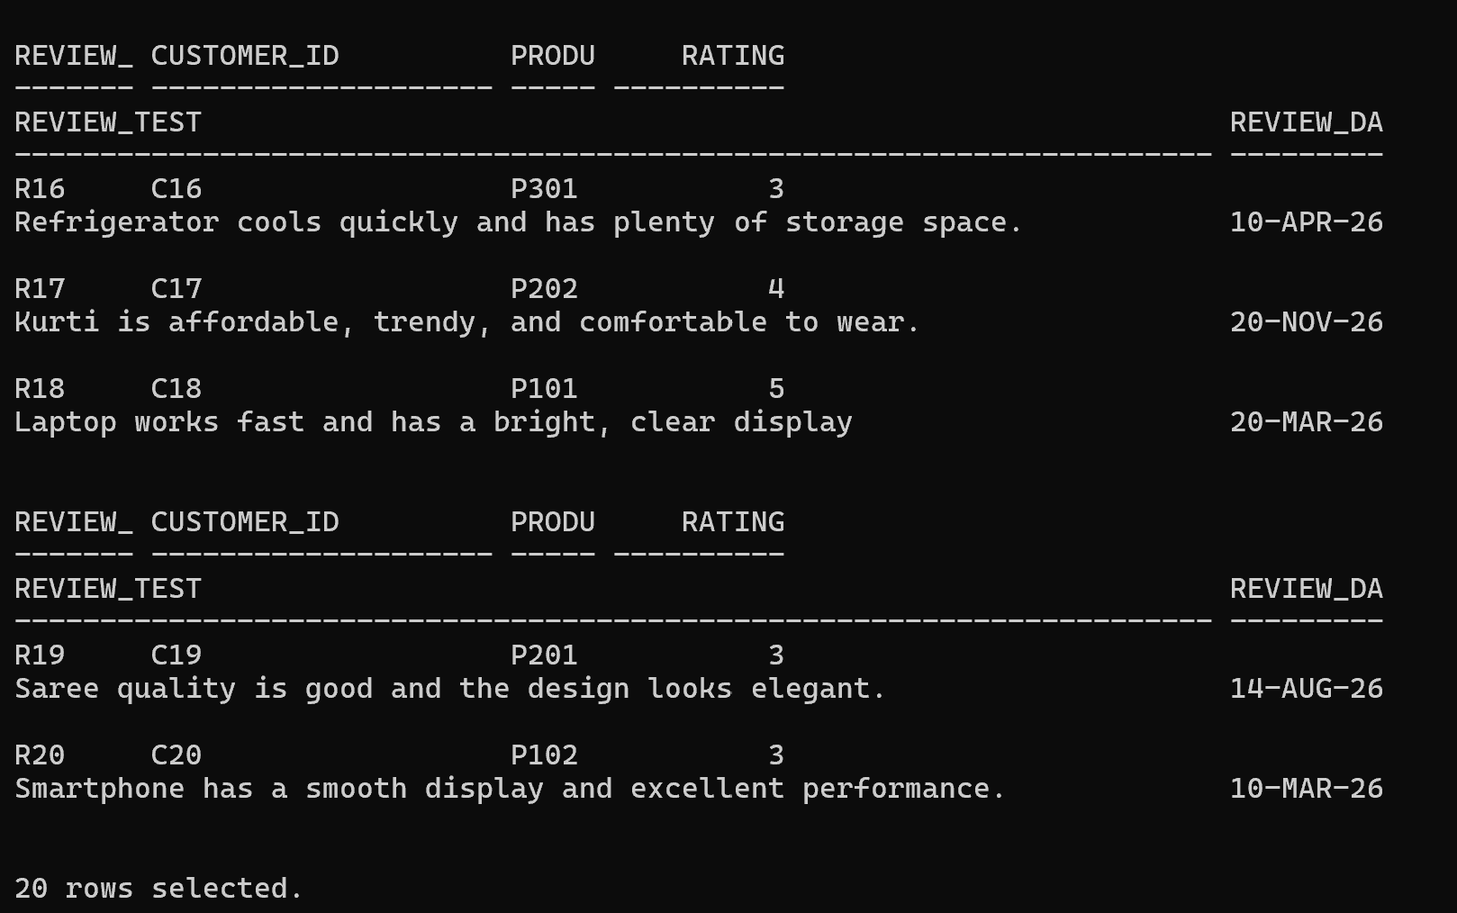
3.Store customer ratings from 1 to 5 stars.
Ensure this by adding Constraint
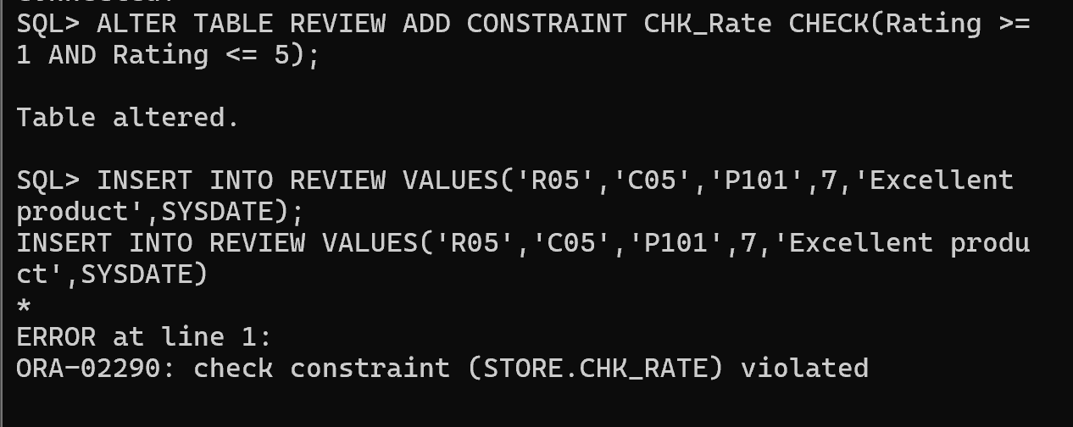
4.Update review comments if required.
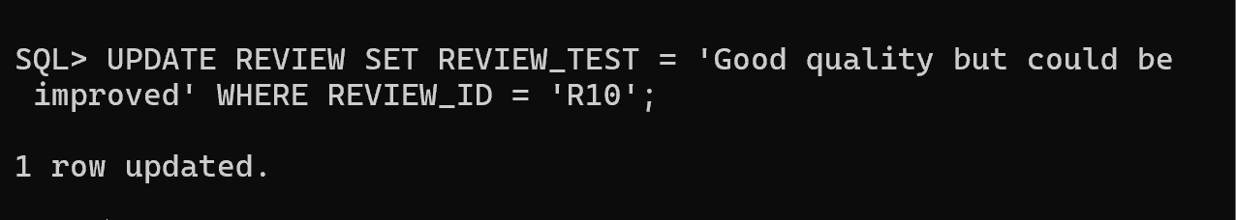
5.Remove inappropriate or invalid reviews.
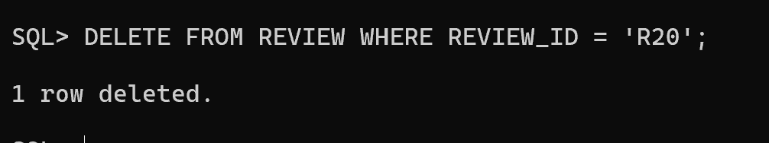

Retrieve Product Review Details
- Display all reviews for a product.
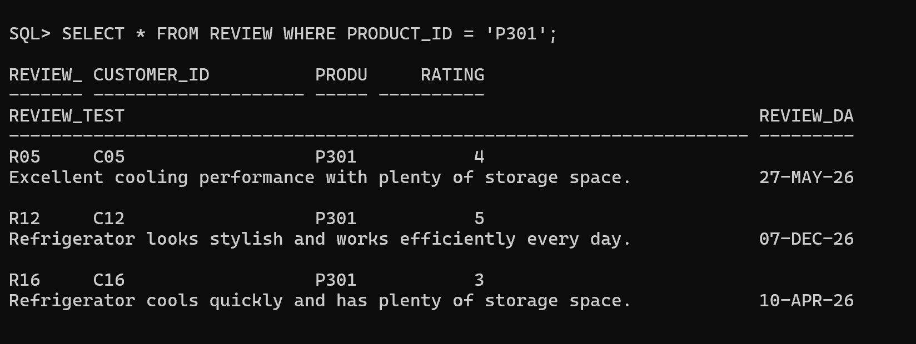
- Display customer name with their reviews.
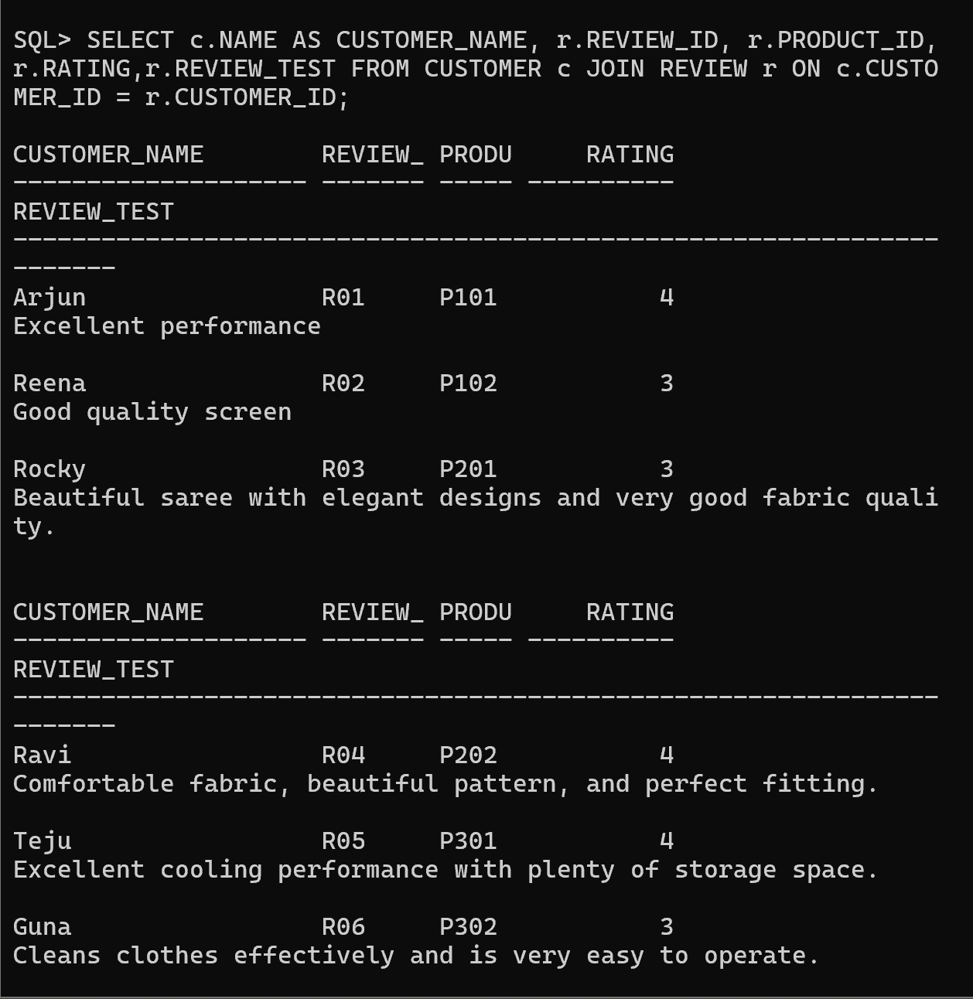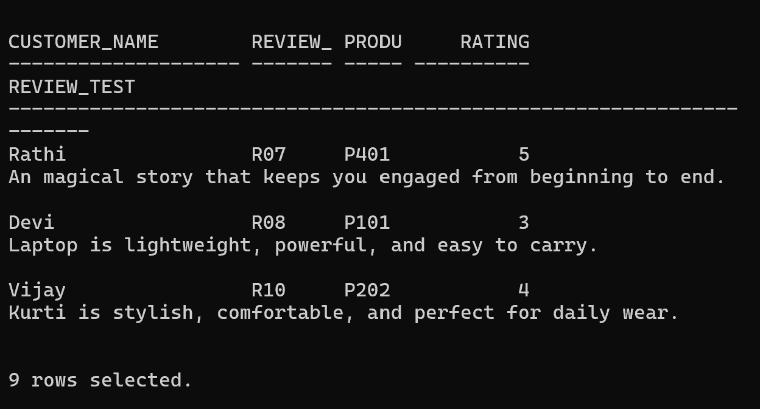
- Find products having maximum reviews.
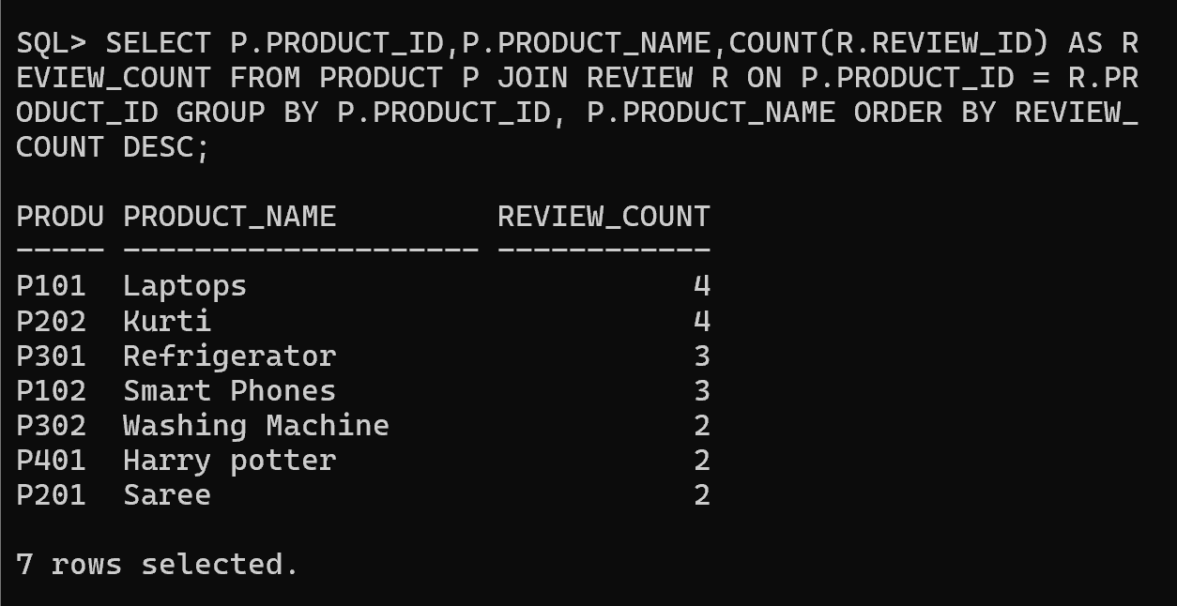

- Display recent customer feedback.
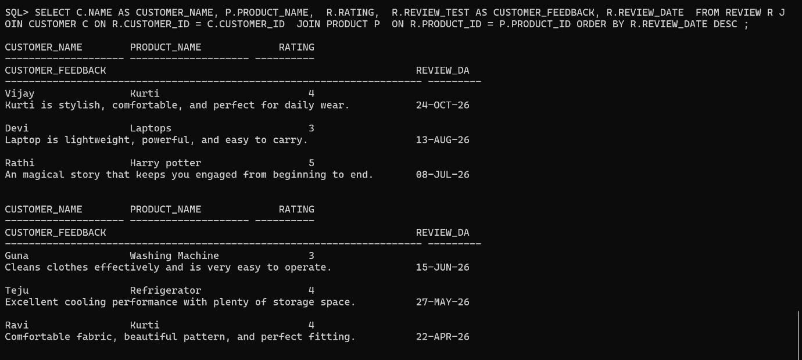
- Retrieve reviews with ratings above 4.
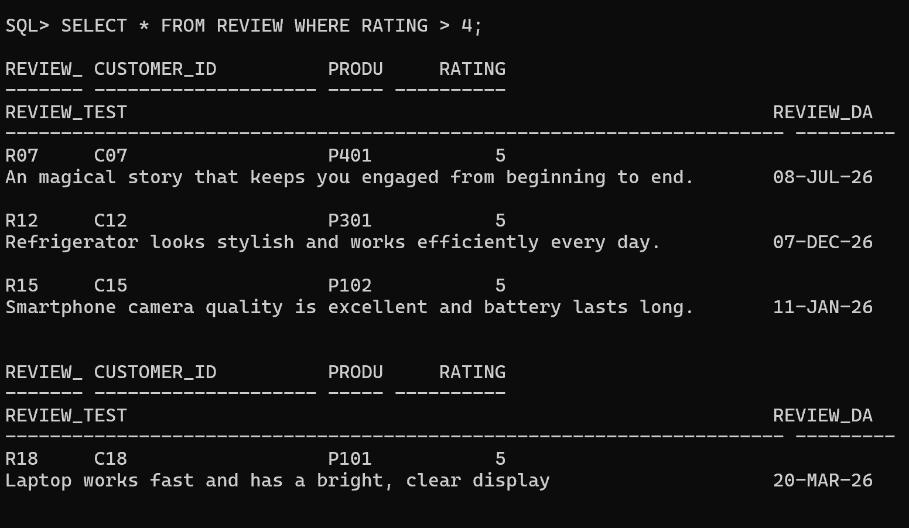
Calculate Average Product Ratings
- Calculate average rating for each product.
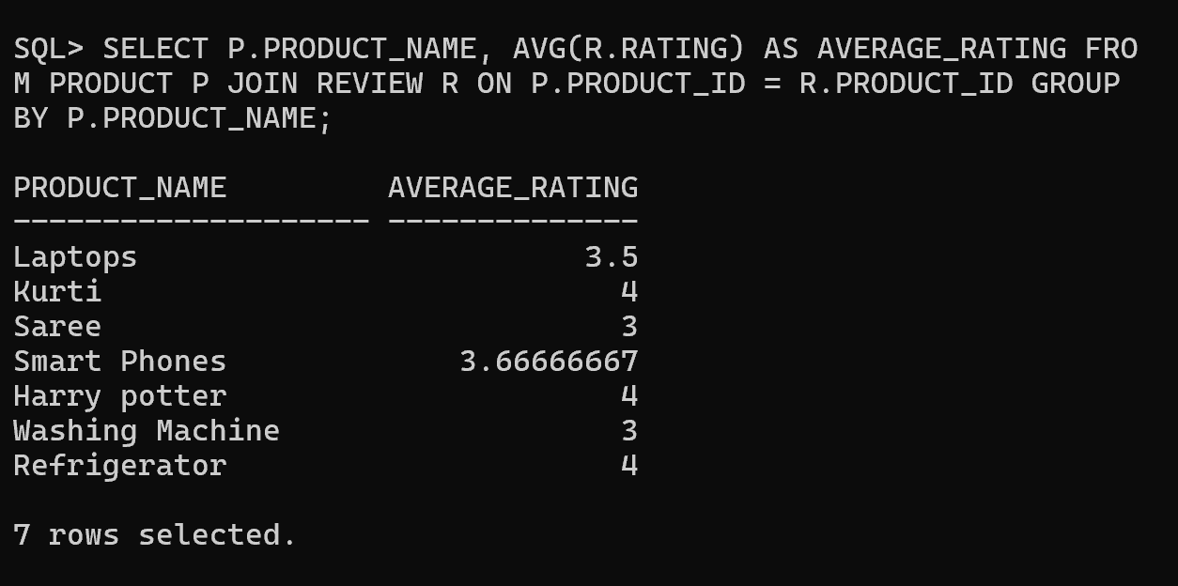
- Count the number of reviews per product.
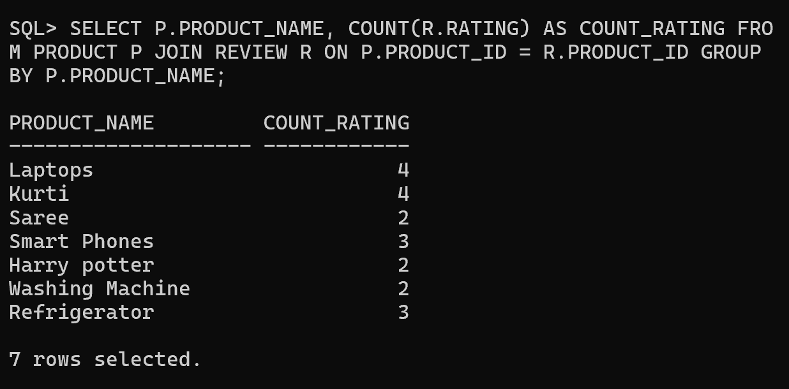
- Find highest-rated products.
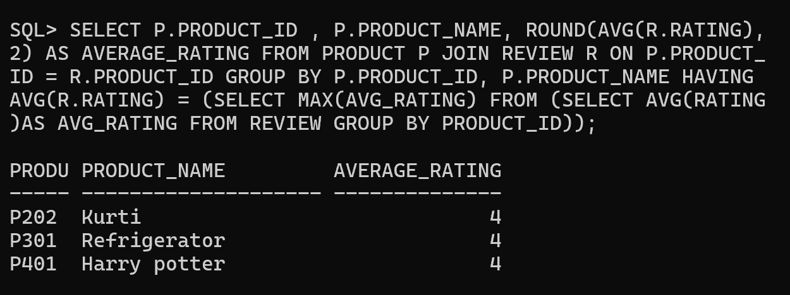
Identify Highly Rated Products
- Product Rating Analysis
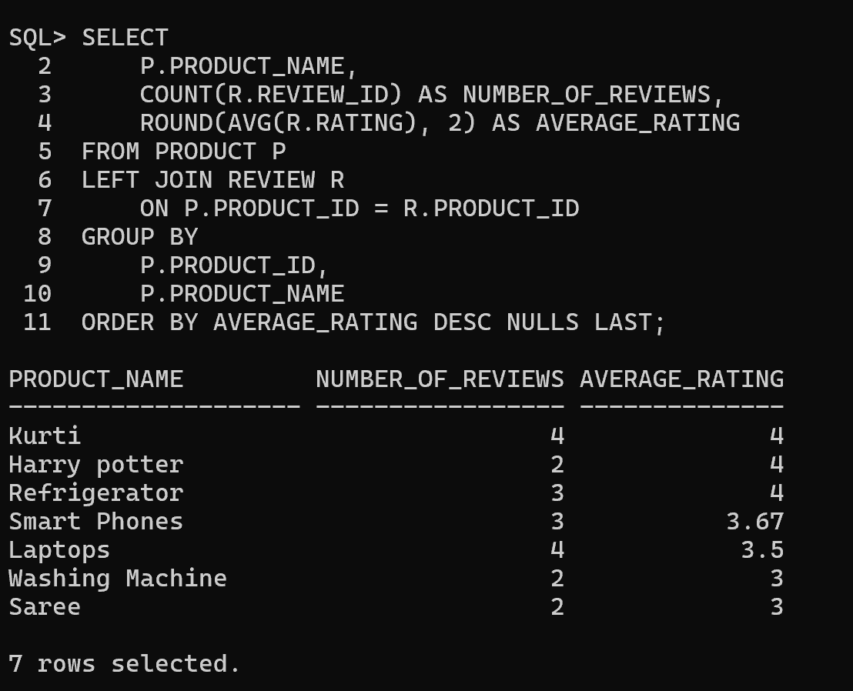
- Customer Feedback Analysis - Most reviewed products
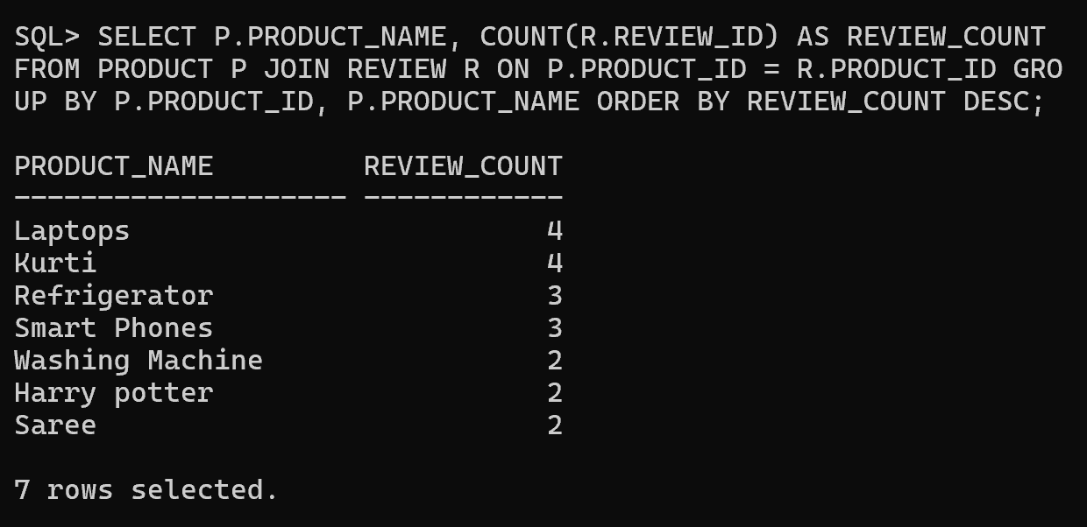
- Customer Feedback Analysis- Highly rated products

- Rating Distribution- Number of 5-star ratings
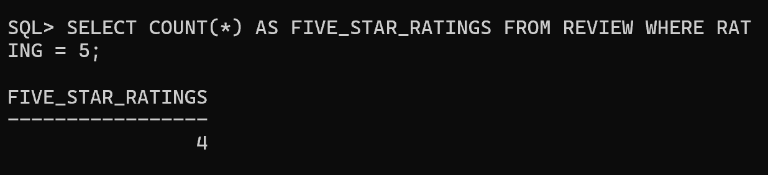
- Rating Distribution- Number of 4-star ratings
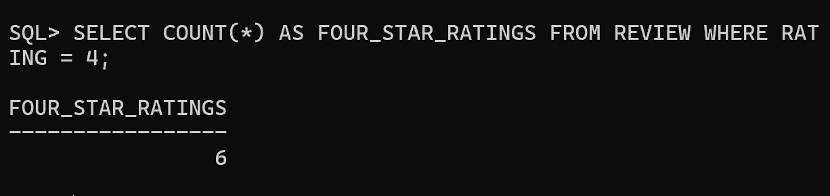
- Rating Distribution- Number of low-rated products
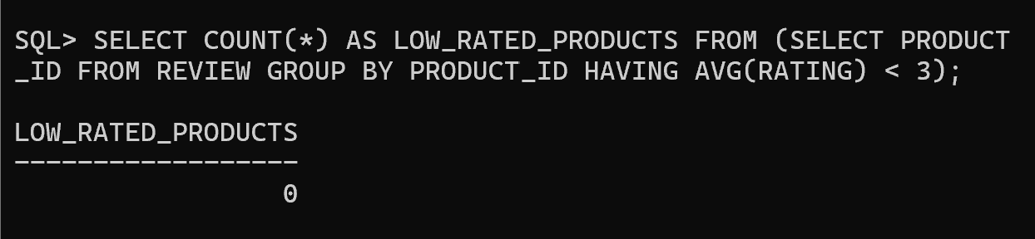
- Rating Distribution- Complete Rating
